Who Will Succeed Mitch McConnell? 3 Likely Candidates for Minority Leader
BY JAMES BICKERTON ON 7/28/23 AT 7:41 AM EDT

https://www.newsweek.com/who-will-succeed-mitch-mcconnell-likely-candidates-minority-leader-1815959
CONTINUE
Play
Unmute
Current Time 0:00
/
Duration 0:39
Loaded: 81.70%

Quality
Fullscreen
Republican Senate leader Mitch McConnell abruptly froze and stopped talking during his weekly press conference on Wednesday, after which he was led away from reporters by several of his GOP colleagues. The incident, which came after McConnell was hospitalized in March after a fall, sparked questions about who could succeed the Kentucky Republican as Senate minority leader should he heed calls to resign over his health.
McConnell, aged 81, later returned to the press conference telling reporters he felt "fine." He said he'd taken a call from a concerned Joe Biden, telling the president he "got sandbagged" in reference to an incident where the commanded-in-chief fell over during a graduation ceremony in June.
As Senate Minority Leader, McConnell is one of the most powerful Republican figures, meaning any replacement candidate is likely to play a major role in determining the party's future. Notably, McConnell has a tense relationship with former president Donald Trump, who labelled him a "disaster" in March, just hours after he was discharged from hospital.
Speaking to Newsweek, Michael Zona, formerly GOP Senator Chuck Grassley's communications director and head of the Bullpen Strategy Group consultancy, said he "would expect a contest" for the Republican Senate leadership if McConnell chooses to step down.
ADVERTISING
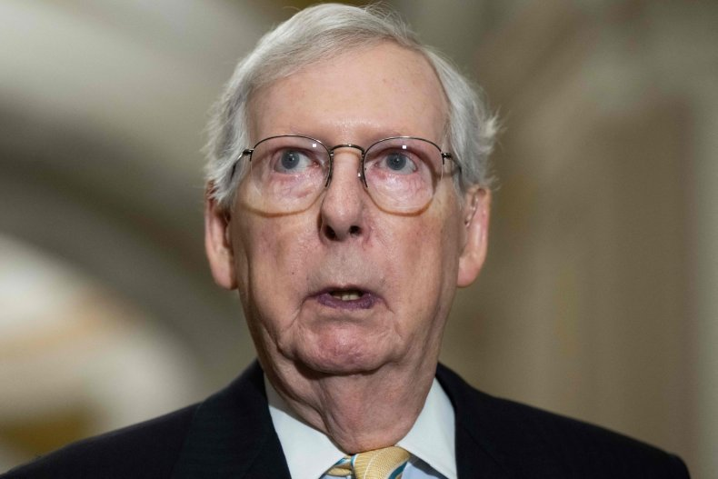
U.S. Senate Minority Leader Mitch McConnell in Washington, D.C., on July 11, 2023. Concerns about McConnell's health have sparked speculation about his possible successor. GETTY/SAUL LOEB / AFP
Referring to the minority leader, he said: "He's wisely mentored several potential successors, preparing them with key committee assignments and leadership roles over the past decade. There are several qualified contenders who are ambitious and have been serving patiently, waiting for the opportunity to lead."
Three men are widely believed to be potential candidates to replace McConnell when he eventually leaves office. These are Senate Minority Whip John Thune, former Republican Whip John Cornyn, and John Barrasso, who chairs the Senate Republican Conference.
Zona agreed these are the primary candidates, stating: "These three have been thought of as potential successors for years now. Each comes with their own strengths and potential bases of support within the caucus, which can be regional or ideological, but is mostly based on relationships with their fellow senators.
"They are all similarly conservative, but they do differ on some issues, such as certain immigration and energy policy areas. The outcome is mostly dependent on their reputations and friendships within the caucus, which can be very personal for each senator, so predictions as to outcomes are difficult."
Newsweek has provided a brief summary of each of the three Republican senators.

Senator John Thune
Thune has enjoyed a long Congressional career, serving in the House of Representatives between 1997 and 2003 before being elected as a South Dakota senator in 2004, a position he has held ever since. Thune's 2004 victory saw him narrowly unseat then Democratic Party leader Tom Daschle.
In 2020, Thune was selected as the Republican whip replacing the term limited Cornyn. There was speculation over whether Thune would run again in 2022, following attacks from Trump, with the Republican telling Politico the prospect of becoming the Republican Senate leader "put additional weight on the side of staying around."

Senator John Cornyn
Texas Republican Cornyn was first elected to the Senate in 2002, having previously worked in real estate and law. In 2003, he became a member of the GOP's whip team and rose to minority whip in 2012, eventually stepping down from the top post after being term-limited.
Cornyn has expressed an interest in being the GOP's Senate leader, commenting in December 2022: "That is something I'd like to pursue.
"It's a unique sort of a race because you know who the voters are, and it's not really influenced by outside influences. It's really more of a matter of relationships and trust."
Speaking to Politico, Maine Republican Senator Susan Collins described Cornyn as "the logical successor" to McConnell, when he decides to step down.

Senator John Barrasso
Barrasso worked as an orthopedic surgeon before being elected to the Wyoming Senate in 2002 as a Republican, holding the role until 2007. That year, he was appointed to the Senate representing Wyoming, winning a special election the following year.
He currently serves as chairman of the Senate Republican Conference, making him the third highest-ranking GOP senator after McConnell and Thune.
Newsweek has contacted Senators Thune and Barrasso for comment via the contact forms on their official websites, and Cornyn by telephone and voicemail message.
Update 7/28/2023, 8:287 a.m. ET: This article has been updated with additional information.

